NET731 FA3 WEEK 2
NHLANHLA J NKOSI
20232271
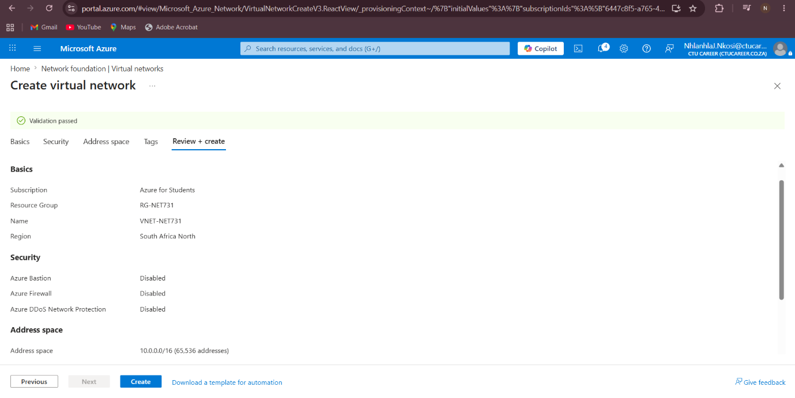
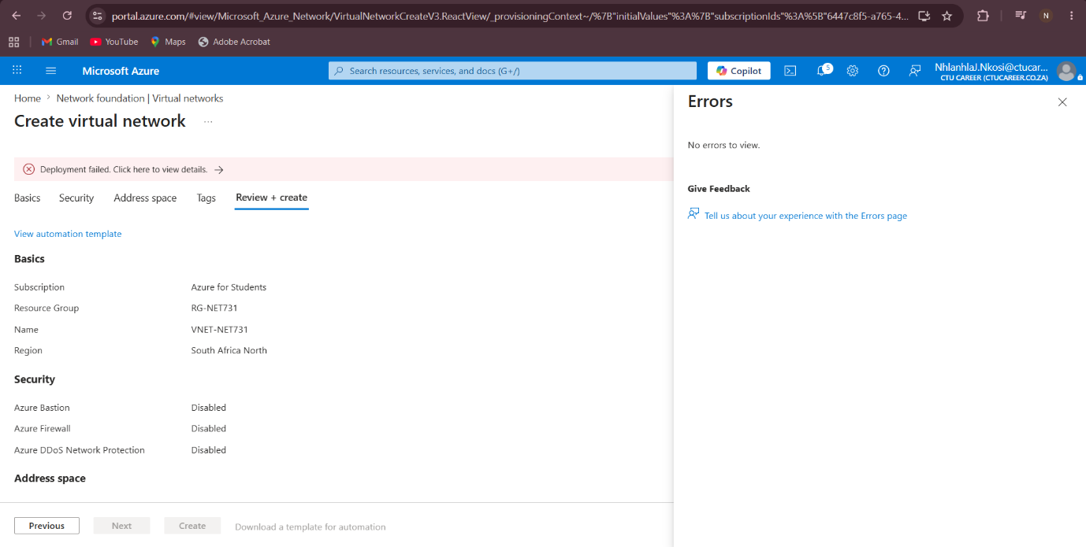
Steps I was going to do:
- Sign in to the Azure Portal.
- Open the “Resource Groups” service.
- Select “Create Resource Group”.
- Enter the following details:
  - Resource Group Name: RG-NET731
  - Region: East US
Review the settings and create the Resource Group.

Task 2 — Create a Virtual Network and Subnet
Steps I was going to do:
- Open the “Virtual Networks” service.
- Select “Create”.
- Configure the following:
=Virtual Network Name: VNET-NET731
=Address Space: 10.10.0.0/16

- Create a custom subnet with:
=Subnet Name: Subnet-Servers
=Subnet Range: 10.10.1.0/24
- Review and create the Virtual Network.

Task 3 — Deploy the Virtual Machine
Steps I was going to do:
- Open “Virtual Machines”.
- Select “Create Virtual Machine”.
- Configure the following settings:
=VM Name: VM-NET731
=Region: East US
=Operating System: Ubuntu Server 22.04 LTS
=VM Size: Standard_B1s
Configure authentication using a username and password.
Allow SSH inbound traffic on port 22.
Attach the VM to the previously created Virtual Network and subnet.
The B1s VM size was selected because it is affordable and suitable for learning environments.

Task 4 — Configure Networking
Steps I was going to do:
- Create a new Public IP resource.
- Set the Public IP assignment to Static.
- Configure a Network Security Group (NSG).
- Add an inbound security rule:
=SSH Port 22 for Ubuntu access.
- Associate the NSG with the VM network interface.
This configuration would allow secure remote access to the VM while maintaining proper network security.

Task 5 — Enable Auto-Shutdown
Steps Intended:
Open the VM Management settings.
Enable Auto-Shutdown.
Configure the shutdown time to 19:00 daily.
Auto-shutdown helps reduce unnecessary Azure costs by automatically turning off unused resources.

